Tran Minh Tuan

12061601

Assignment 2

DATABASE DESIGN & IMPLEMENTATION COIT11237

## Part A:

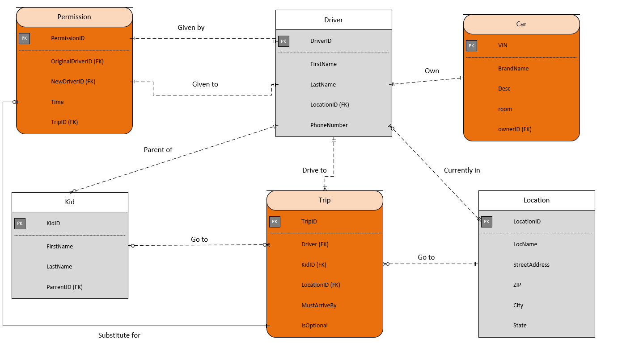

Assumption:

* Each trip has no more than 1 kid. When a driver drives multiple kids to the same location at the same time, it will be considered as multiple trips.
* A trip has 2 locations, the starting location where the driver currently is and the destination location. After finishing the trip, the location of the driver will be updated.
* The room in the car will be calculated by decreasing the number when the trip is assigned to a driver and increase it after the trip finish or was passed to another driver.
* 2 locations are considered as close if they have the same ZIP (in the same suburb).
* Each driver only driver 1 car at a time so only 1 needed to be recorded.

## Part B:

1. Relational database design:

* Location (LocationID, LocName, StreetAddress, ZIP, City, State)
* Driver(DriverID, FirstName, LastName, LocationID, PhoneNumber)
  + Foreign key (LocationID) references & must exist in Location (LocationID).
    - Don’t cascade update from Driver because LocationID is probably a surrogate key
    - Don’t cascade deletes from Location
* Kid(KidID, FirstName, LastName, ParrentID)
  + Foreign key (ParrentID) references & must exist in Driver(DriverID)
    - Don’t cascade update from Driver because DriverID is probably a surrogate key
    - Don’t cascade deletes from Driver
* Car(VIN, BrandName, Desc, Room, Owner)
  + Foreign key (Owner) references & must exist in Driver(DriverID)
    - Don’t cascade update from Driver because DriverID is probably a surrogate key
    - Cascade deletes from Driver
* Trip (TripID, Driver, Kid, LocationID, MustArriveBy, IsOptional)
  + Foreign key (Driver) references & must exist in Driver(DriverID)
    - Don’t cascade update from Driver because DriverID is probably a surrogate key
    - Don’t cascade delete from Driver.
  + Foreign key (Kid) references Kid(KidID)
    - Don’t cascade update from Kid because KidID is probably a surrogate key
    - Don’t cascade deletes from Kid.
  + Foreign key (LocationID) references & must exist in Location(LocationID)
    - Don’t cascade update from Location because LocationID is probably a surrogate key.
    - Cascade deletes from Location.
* Permission(PermissionID, OriginalDriver, NewDriver, Time, Trip)
  + Foreign key (OriginalDriver) references & must exist in Driver(DriverID)
    - Don’t cascade update from Driver because DriverID is probably a surrogate key
    - Cascade deletes from Driver.
  + Foreign key (NewDriver) references & must exist in Driver(DriverID)
    - Don’t cascade update from Driver because DriverID is probably a surrogate key
    - Cascade deletes from Driver.
  + Foreign key (Trip) references & must exist in Trip(TripID)
    - Don’t cascade update from Driver because TripID is probably a surrogate key
    - Cascade deletes from Trip.

1. Database implementation:

* Primary Key Constraint: Driver, Kid, Permission, Trip, Location has been set to be AutoNumber, Car’s Primary Key (VIN) is Short Text
* Foreign Key Constraint:
  + Car’s Owner references Driver’s DriverID, is required and must be unique
  + Trip’s Driver references Driver’s DriverID and is required
  + Trip’s Kid references Kid’s ID and is not required
  + Kid’s Parrent references Driver’s DriverID, is required
  + Permission’s NewDriver references Driver’s DriverID, is required
* Cascade delete: Car’s Owner cascade deletes Driver’s DriverID
* Validation rule with validation text: Car’s room must be larger than 0
* Table constraint: Driver’s first name and last name must be different.